hi

Final Examination
(Fall, 2001-2002)

ENGG 201 - Behaviour of Liquids, Gases and Solids

December 13, 2001 Time Allowed: 180 minutes.

- Attempt all six (6) questions. Weighting as noted. Total marks = 100.
- The textbook and electronic calculators are permitted. Notes are not allowed.
- Print your name clearly in the space provided on the cover page. Write your ID No. on the last page and all other pages in the provided space.

Surname: ___SOLUTION_______ Given Name(s):____________________ Section* ______

*L01 for MWF Lectures (Dr. Maini);
L02 for T R Lectures (Dr. Azaiez).

STUDENT IDENTIFICATION
Each candidate must sign the Seating List confirming presence at the examination. All candidates for final examinations are required to place their University of Calgary student l.D. cards on their desks for the duration of the examination. (Students writing mid-term tests can also be asked to provide identity proof.) Students without an l.D. card who can produce an acceptable alternative l.D. e.g. one with a printed name and photograph, are allowed to write the examination.
A student without acceptable l.D. will be required to complete an Identification Form. The form indicates that there is no guarantee that the examination paper will be graded if any discrepancies in identification are discovered after verification with the student's file. A Student who refuses to produce identification or who refuses to complete and sign the Identification Form is not permitted to write the examination.

EXAMINATION RULES
(1) Students late in arriving will not normally be admitted after one-half hour of the examination time has passed.
(2) No candidate will be permitted to leave the examination room until one-half hour has elapsed after the opening of the examination, nor during the last 15 minutes of the examination. All candidates remaining during the last 15 minutes of the examination period must remain at their desks until their papers have been collected by an invigilator.
Question  No. | Maximum  Mark | Mark  Obtained
I | 15
II | 15
III | 20
IV | 15
V | 20
VI | 15
Total (out of 100)

(3) All inquiries and requests must be addressed to supervisors only.
(4) Candidates are strictly cautioned against:
(a) speaking to other candidates or communicating with them under any circumstances whatsoever: (b) bringing into the examination room any textbook, notebook or memoranda not authorized by the examiner;
(c) making use of calculators and/or portable computing machines not authorized by the instructor: (d) leaving answer papers exposed to view;
(e) attempting to read other student's examination papers.

The penalty for violation of these rules is suspension or expulsion or such other penalty as may be determined.
(5) Candidates are requested to write on both sides of the page, unless the examiner has asked that the left hand page be reserved for rough drafts or calculations.
(6) Discarded matter is to be struck out and not removed by mutilation of the examination answer book.
(7) Candidates are cautioned against writing in their answer book any matter extraneous to the actual answering of the question set.
(8) The candidate is to write his/her name on each answer book as directed and is to number each book.
(9) A candidate must report to a supervisor before leaving the examination room.
(10) Answer books must be handed to the supervisor-in-charge promptly when the signal is given. Failure to comply with this regulation will be cause for rejection of an answer paper.
(11) If during the course of an examination a student becomes ill or receives word of domestic affliction, the student should report at once to the supervisor, hand in the unfinished paper and request that it be cancelled. If physical and/or emotional ill health is the cause, the student must report at once to a physician/counsellor so that subsequent application for a deferred examination is supported by a completed Physician/Counsellor Statement form. Students can consult professionals at University Health Services or university Counselling
Problem I: (15 points)
The inclined pipe shown in the figure is used to carry oil (ρ=900kg/m³, μ=9x10⁻³Pa.s). The pipe is made of steel, has a diameter D=20cm and a length L=300m.
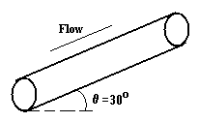

(a) Determine the pressure drop if the average velocity in the pipe is equal to 3m/s. (10 marks)

Re = ρuD/μ = 900*3*0.2/0.009 = 6x10⁴
➔ The flow is turbulent, and f ≈0.006 (Chart)
-( ΔP+ ρgΔh) = 2f u² ρL/D
Δh= L.sin(θ)
-ΔP= 2f u² ρL/D + ρg L.sin(θ)
= 2*0.006*(3)²*900*300/0.2 +900*9.81*300*sin(30)
=1.47 MPa
Pressure Drop=1.47 MPa

(b) What would be the pressure drop for the same average velocity if the oil is treated as an ideal (inviscid) fluid. (5 marks)

If the flow was considered as inviscid, then the viscous losses are zero and,
-ΔP = ρgΔh = ρgL.sin(θ) =
= 900*9.81*300*sin(30)
= 1.32 MPa
N.B. This result can be also obtained from Bernoulli equation:
P/ρ +u²/2 + gh=c^{st}

Pressure Drop=1.32 MPa

Problem II: (15 points)
A 250m³ tank contains 2300kg of a mixture of CO₂ (M=44kg/kmol) and CH₄ (M=16kg/kmol). The pressure and temperature in the tank are 1MPa and 300K respectively.

(a) Calculate the mole fraction of CH4 in the mixture using the ideal gas assumption. (6 marks)
n = PV/RT = 1,000,000 * 250/(8.314 * 300) = 100233 mol = 100.233 kmol
Average molar mass = 2300 kg/100.233 kmol = 22.95 kg/kmol
Let x be the mole fraction of CH4 in the mixture. Then the average molar mass is given by:
16 * x + 44 * (1-x) = 22.95, or
28 x = 21.05 or x = 0.752
Mole fraction of CH₄ in the mixture is 0.752
Mole fraction of CO₂ in the mixture is 0.248

(b) Given that the tank now contains 1,600kg of methane and 4,400kg of CO₂ at 300K, calculate the pressure in the tank using Kay’s rule and the compressibility factor chart. (9 marks)

Component | Mass, kg | kmol | Mole Fract. | T_{c}, K | P_{c}, atm | y_{i}.T_{c} | y_{i}.P_{c}
CH₄ | 1600 | 100 | 0.5 | 190.6 | 45.4 | 95.3 | 22.7
CO₂ | 4400 | 100 | 0.5 | 304.2 | 72.8 | 152.1 | 36.4
SUM |  |  |  |  |  | 247.4 | 59.1

T_{r} = 300/247.4 = 1.21

P_{r} is to be calculated, but we need P_{r} to look up the value of Z. This will require a trial and error procedure.

To start with assume Z = 1.0 and calculate P and P_{r}. Use this P_{r} and the previously calculated T_{r} to obtain a value of Z from the chart.
Recalculate P using this value of Z and continue the iteration until convergence is achieved. These calculations are summarized below.

Z=PVm/RT=Rv/(nRT)=5.01x10⁻⁷ P ➔ P=1995360.Z
P_{r}=P/P_{pc}=P/(59.1x101325)=1.67x10⁻⁷ P

Z | P (Pa) | Pr | Revised Z
1 | 1995360 | 0.333 | 0.93
0.93 | 1855684.8 | 0.310 | 0.92
0.92 | 1835731.2 | 0.307 | 0.92

P=1835.731kPa

Problem III: (20 points)
The following information is available on pure component properties of ethylene and propane.
Component | Normal boiling point, (K) | Latent heat of vaporization,  (kJ/kmol)
Propane | 231 | 19600
Ethylene | 169 | 13500
- Using this information, determine the relationship between the temperature and vapour pressures for propane and ethylene, i.e. calculate the values of A and B in the equation 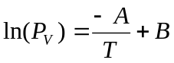, for both components (Use units of kPa for P_{v}). (8 marks)
For Propane: A = ΔH_{v}/R = 19600 (kJ.kmol)/8.314 (kJ/kmol.K) = 2357.47 K
At normal boiling point P_{v} = 101.325 kPa, therefore
ln(101.325) = -2357.47/231 + B ➔ B = 14.82

For Ethylene: A = ΔH_{v}/R = 13500 (kJ.kmol)/8.314 (kJ/kmol.K) = 1623.77 K
At normal boiling point P_{v} = 101.325 kPa, therefore
ln(101.325) = -1623.77/169 + B ➔ B = 14.23

(b) A two-phase vapour-liquid mixture of ethylene and propane is kept in a tank at a temperature of 250 K. Given that the vapour phase at equilibrium contains 40 mol% propane, use Raoult’s law to calculate the pressure of the mixture and mole percent of propane in the liquid phase.

From Raoult’s Law
P₁ = x₁P_{v1}, or, x₁ = P₁/P_{v1} = y₁P/P_{v1}
and
P₂ = (1-x₁) P_{v2}, or, x₂ = P₂/P_{v2} = y₂P/P_{v2}
also, x₁ + x₂ = 1, therefore
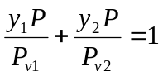. or
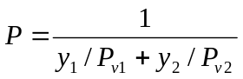

At 250 K,
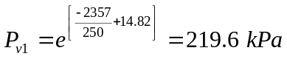, and 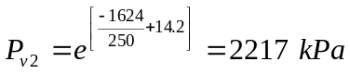
Hence,
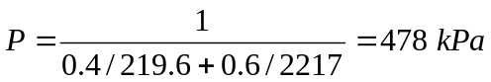

P = P_{v1}x₁ + P_{v2}(1-x₁)
478 = 219.6x₁ + 2217(1-x₁) or
1997x₁ = 1739, or
x₁ = 1739/1997 = 0.87
x₂ = 1-x₁ = 0.13

Problem IV: (15 points)
Two insulated steel pipes are carrying 200ºC steam. The internal diameter of both pipes is 2.0cm and both are insulated with 2.5cm thick layer of asbestos on the outside. The wall thickness of the first pipe is 0.5cm while the wall of the other pipe is 2.0cm thick. The temperature at the outside surface of the insulation is kept constant at 25ºC. Thermal conductivities of steel and asbestos are 50 W/mK and 0.15 W/mK respectively.

(a) Calculate the rate of heat loss per unit length for both pipes. (6 marks)
For thin walled pipe:
r₁ = 1.0 cm, r₂ = 1.5 cm, r₃ = 4 cm, κ₁ = 50 W/mK and κ₂ = 0.15 W/mK
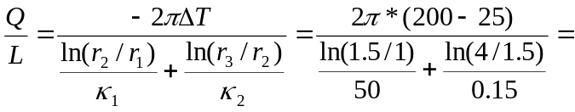 167.9 W/m
Q/L=167.95 W/m
For thick walled pipe:
r₁ = 1.0 cm, r₂ = 3.0 cm, r₃ = 5.5 cm, κ₁ = 50 W/mK and κ₂ = 0.15 W/mK
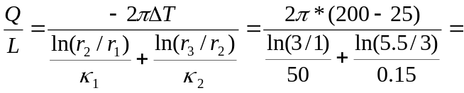 270.9 W/m
Q/L=270.63 W/m

(b) Calculate the temperature at the interface between the steel and the insulation in case of the thicker pipe. (6 marks)
Considering the heat transfer only in the steel for the case of thick pipe,

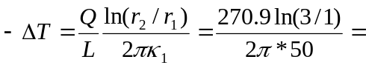 0.95 ºC
Temperature at the interface = 200 – 0.95 = 199.05 ºC
T=199.05 ºC

(c) Explain why the thick walled pipe looses more heat. (3 marks)
In this situation the steel offers very little resistance to heat loss. The temperature drop in the steel is less than 1 ºC, even for the thick pipe. In the case of the thick walled pipe a much larger area of the outer steel surface is maintained at high temperature. This larger area results in larger heat loss, even though the temperature difference across the insulation layer would be slightly smaller in the case of thicker pipe.

Problem V: (20 points)
(a) The mean free path of a gas at a temperature T₁ and a pressure P₁ is 7*10⁻⁵cm. At these temperature and pressure, there are 2*10¹⁸ molecules/cm³.
Use results from kinetic theory to determine the collision diameter, σ. (5 marks)
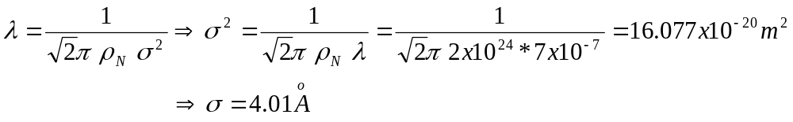
σ =4.010 Angstrom
(b) The pressure of the gas is doubled such that P₂=2*P₁, while keeping its temperature fixed. What is the new value of the mean free path? (3 marks)
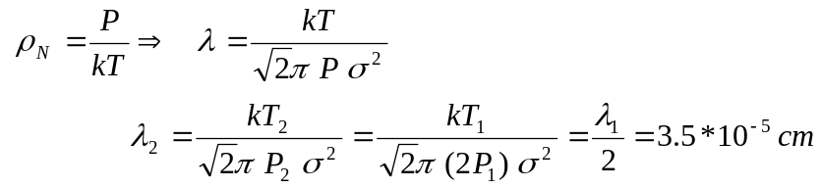
λ = 3.5*10⁻⁵ cm

(c) The gas is now held in a cubic container of side a. The temperature T of the container is kept constant. One of the walls of the container has a small circular hole of radius r, from which the gas escapes. If we call X_{n} the fraction of molecules of the gas that escape through the small hole after a time Δt, show that X_{n} and Δt are given by the following relationship:
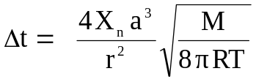
(Assume that the pressure remains constant in the container). (10 marks)
The collision rate per unit area: 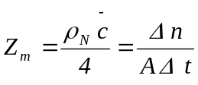
➔ 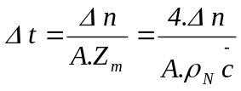
The fraction of molecules lost is X_{n}=Δn/n₁ ➔ Δn= X_{n}.n₁
but n₁=ρ_{n}.v =ρ_{n}.a³, therefore: Δn= X_{n}.ρ_{n}.a³

➔ 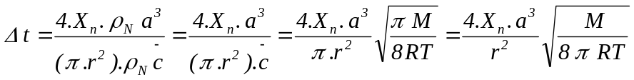

(d) Determine the time Δt for the container to lose 10% of the gas, if M=40kg/kmol, T=300K, a=20cm and r=0.1mm. (2 marks)
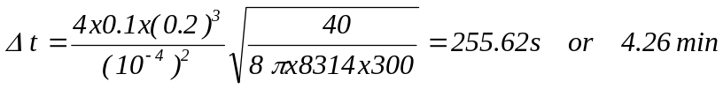
Δt =255s=4.26min

Problem VI: (15 points)
Consider a metal that has a cubic shape and which is
subject to forces in the x and y directions as shown in the figure. Note that there are no forces applied in the z-direction.
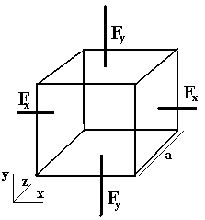

(a) Show that if the tensile force in the x-direction and the compressive force in the y-direction have the same magnitude, then there is no change in the volume of the cube, i.e. ΔV=0. (6 marks)
For the system of forces shown in the figure we
have:
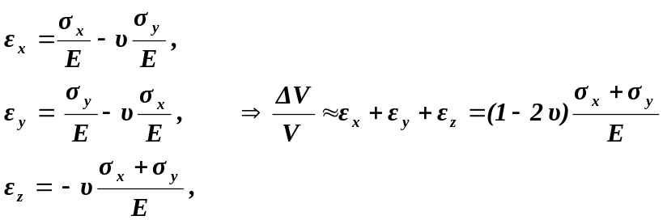 But σ_{x}= F_{x}/A and σ_{y} = -F_{y}/A. Therefore if |F_{x} |= |F_{y} |, then σ_{x} + σ_{y} =0 or ΔV=0.

(b) It is found that if the magnitudes of the forces in the x and y directions are equal to 200N and 100N respectively, the relative change in the volume of the cube ΔV/V, is equal to 10⁻⁵. We give a=1cm, and the Poisson ratio ν=0.4. Determine:
- The value of the Young modulus of the metal. (3 marks)
σ_{x}= F_{x}/A= F_{x}/a² = 200/(0.01)²=2*10⁶Pa.
σ_{y}=-F_{y}/A=-F_{y}/a²=-100/(0.01)²=-10⁶Pa.
σ_{z} = 0
Therefore from Eq. 10.16

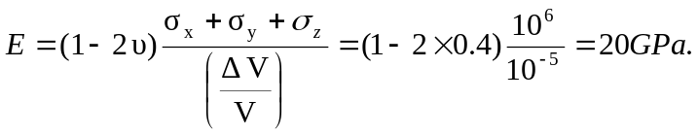
E =20.0GPa
(ii) The value of the Shear modulus of the metal. (3 marks)
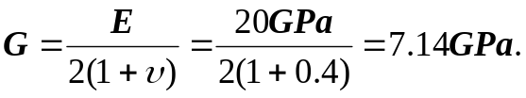
G =7.14GPa
(iii) The value of the strain in the x-direction, ε_{x}. (3 marks)
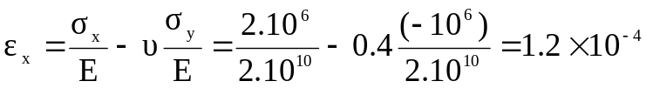

ε_{x} =1.2x10⁻⁴

*************************

